**Table of Contents**

Project Overview …………………………………………………………………………….…….. 1

Team Progress Summary ………………………….………………………..…………..………... 2

Reference …………………………………………………………………...…………......……….. 3

Appendix A Gantt Chart …………………………….……………..……….……….……………. 4

Appendix B Test Document ……………………………..…..…….……………....…………….. 6

Appendix C Blind Spot of the Camera …….………...………….…………………..……..….. 14

Appendix D Height of Object vs. Camera’s Angle of View………..…….……………...…... 15

Appendix E Scanner Prototype …………………………………………...……………..…...... 16

Appendix F Camera Distortion ………………………………………………………...……….. 18

Appendix G 3D Graphics Display on Monitor ………………….……………….…..………... 19

**Project Overview**

The team is to implement a system which is able to observe a tangible object and produce a digital model that resembles the original object. The generated files should be compatible with current CAD programs and 3D printers. To emphasize the importance of affordability and efficiency, the prototype should not cost more than $150, and take no more than 20 minutes to complete the scanning process. Furthermore, the system should be able to support scanning of objects weighing up to 350 grams within physical dimensions of a cylinder of 30 centimeters in radius and height.

The hardware system consists of a rotational plate, a laser, and cameras. The object to be scanned is placed at the center of the plate which rotates at fixed intervals until 360 degrees is achieved. As the plate rotates, a laser continuously shines a vertical beam of light on the object and photos are taken by the cameras. The team has decided to implement the system with 2 cameras to obtain data from the side views of the object as well as the top view.

After the hardware obtains all the picture files of the object, the software begins processing this data by first obtaining the coordinates of the laser beam on each photo, and mapping these points into 3D coordinates using a mapping algorithm. We further process these points by meshing these points into surfaces and presenting the digital replicated object on the monitor in 3D through a graphical display interface we programmed.

The team has come across two problems thus far, both relating to the camera. First, due to the angle separation between the laser and camera, it is possible for the object’s edges to block the laser beam from the camera’s view at certain angles, creating a “blind spot” for the camera. If this happens, we lose certain data points for the side view of the object. See Appendix C for detailed descriptions of this problem. Second, due to the camera’s limited angle of view, the size of the object, mainly the height of the object, that can be successfully scanned is limited by the camera’s specifications. See Appendix D for detailed descriptions of this problem.

**Team Progress Summary**

The team has moved on to implementing the third prototype of the scanner. The size of this prototype has increased from the previous prototype to obtain a greater viewing angle, enabling us to scan larger objects. New features in this prototype include: adding 2nd camera to obtain data from top view of the object, updating the motor support stand with a lazy Susan, using a stepper motor instead of the Servo motor used in the previous prototypes for more accurate and consistent angle of rotation, and adding a safety feature that stops shining the laser as soon as the lid is open to prevent the laser from accidentally shining somewhere it shouldn’t be. See Appendix E for a more detailed overview of this prototype.

The team is also continuously making progress on the software development front. The 3D point mapping for the first camera was implemented prior to the December Design Review. Adding the second camera has introduced additional distortion effects that the team needs to overcome. See Appendix F for details on the distortion from the camera. In addition, the team has also implemented the tool to view the scanned object in 3D on the monitor. See Appendix G for details.

The team has split the responsibility by modules. Sen Yang is responsible for the hardware components as well as some software implementation. Emily Miao is responsible for coming up with the algorithms and refining the software mapping. Jing (Grace) Guan is responsible for implementing the meshing and displaying the scanned object in 3D on the monitor.

As can be seen from the comparison of the two Gantt Charts in Appendix A, one representing the team’s progress to date, and the other from the team’s Final Proposal representing the initial timeline planning, the team is on schedule. Although completion of certain tasks, such as S3 Data Acquisition milestone has been pushed back by a month due to the Final Proposal, we are able to stay on task by taking reducing the time it takes to complete our tasks and also by removing the optional color scanning feature (formerly S5 milestone) from our project.

The reason for removing this feature is in consideration of our project goals. The team is implementing an affordable 3D scanner to be compatible with current affordable 3D printers on the market such that any scanned object can be physically replicated with a 3D printer. However, current color 3D printers in the market tend to be expensive and thus unaffordable by the average household [1]. For example, the Stratasys model is priced at $2500 [1]. As a result, the team has decided that the color scanning feature is not necessary as our goal is to implement an affordable 3D scanner, and the complimentary affordable 3D printers do not support the color 3D printing feature.

**References**

[1] Beth McKenna, “Apple Patent Application Reveals a Killer Color 3D Printer Might Be Coming”, The Motley Fool, [Online] 2015, URL: <http://www.fool.com/investing/general/2015/12/21/apple-patent-application-reveals-a-killer-color-3d.aspx> Accessed: 2016 January

[2] “Object Files”, Paul Bourke, [Online], 2015, URL: http://paulbourke.net/dataformats/obj/ Accessed: 2015 October

[3] “What is an STL File?”, 3D Systems. [Online] 2015, URL: http://www.3dsystems.com/quickparts/learning-center/what-is-stl-file Accessed: 2015 October

[4] “How much does a coffee mug weigh in grams”, ChaCha, [Online] 2011, URL:http://www.chacha.com/question/how-much-does-a-coffee-mug-weigh-in-grams Accessed: 2015 September

[5] “Results for Servo Motors”, Amazon Canada, [Online] 2015, URL: https://www.amazon.ca/s/ref=nb_sb_noss_1?url=search-alias%3Daps&field-keywords=servo+motor Accessed: 2015 October

[6] “The Universal Serial Bus: What it is and how it works”, G. Knagge, [Online] 2015, URL: http://www.geoffknagge.com/uni/elec101/essay.shtml Accessed: 2015 September

[7] “Sardauscan $30 DIY 3D Scanner”, 3D Printing .com, [Online] 2015, URL: http://3dprinting.com/how-to/sardauscan-30-usd-diy-3d-scanner-3d-print/ Accessed 2015 September

[8] “Country Household Voltages and Plug Styles”, PowerStream, [Online] 2015, URL: http://www.powerstream.com/cv.htm Accessed: 2015 September

[9] “ECE496 Course Milestones and Deliverables Summary”, University of Toronto, [Online] 2015, URL: https://internal.ece.toronto.edu/ece496.1415/pages/students/schedule-deadlines.html Accessed: 2015 September

[10] “3D Modelling Tools”, 3D Printing for Beginners, [Online] 2015, URL: http://3dprintingforbeginners.com/software-tools/Acessed: 2015 September

**Appendix A Gantt Chart**

This section includes the most recent Gantt Chart that accurately reflects the team’s progress up to date, see image A.2. This section also includes the Gantt Chart used for initial planning of the project timeline, the same Gantt Chart submitted with the Final Proposal, see image A.1.

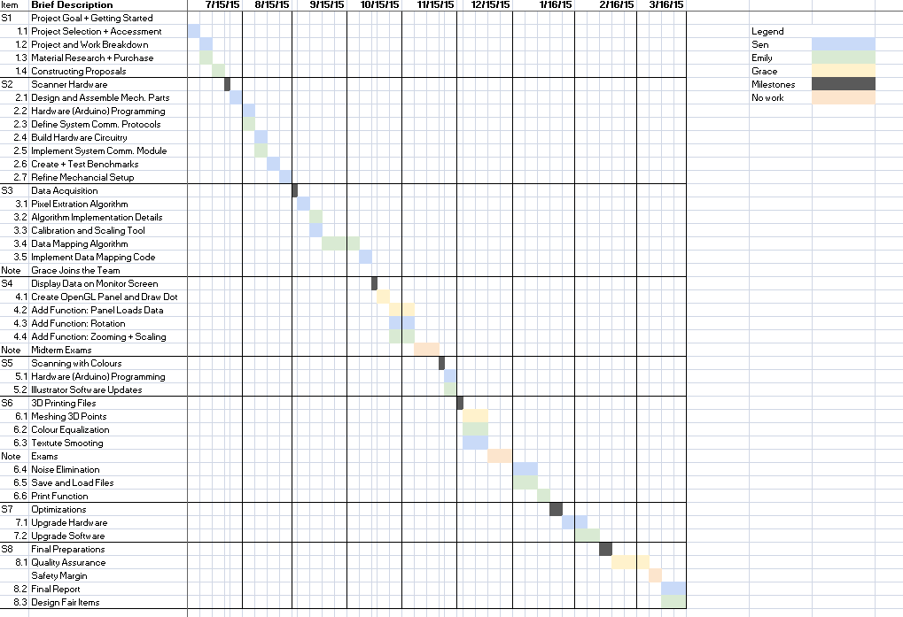

Figure A.1 Initial Gantt Chart from Final Proposal

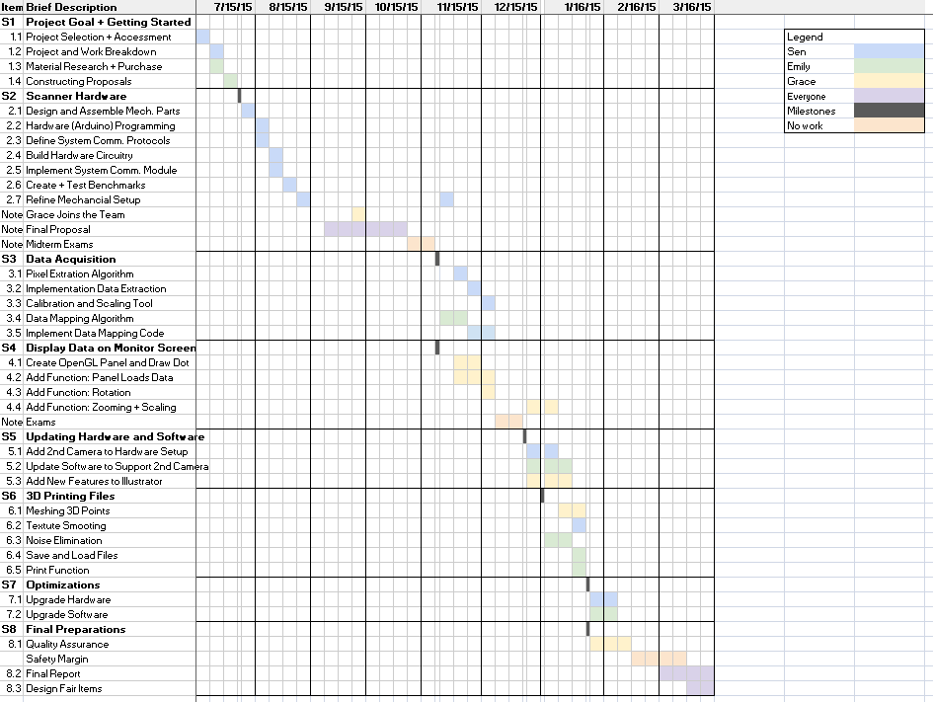

Figure A.2 Current Gantt Chart

**Appendix B Test Document**

This section includes the Test Document that reflects the team’s progress up to date.

**B.1 Project Goal**

The end objective of this project is to implement a scanning system which observes a physical object of limited size and weight, and to digitally produce the corresponding 3D model files for monitor display and 3D printing.

**B.1.1 Project Requirements**

This subsection enumerates the list of project requirements, restrictions, and desirable attributes under objectives.

**B.1.1.1 Functional Requirements**

* The system will accurately produce a 3D digital model of the object observed in .OBJ [2], and .STL format [3] which is a simplification of the .OBJ format for 3D printers. Please refer to Appendix A for details.
* The rotational system will use a stepper motor to expose all 360 degrees of the scanned object to image taking devices. The motor will rotate objects up to 350 grams [4] centered at the axis of rotation. This weight is limited by the torque rating of the selected motor, under a $50 budget [5].
* The produced 3D digital replica must achieve at least a resolution of 10 pixels/cm2 from the surface of the scanned object. This is set by an optimal tradeoff point between the requirements of model definition and model data processing speed.
* The system will receive commands and send produced files to connected computer via an USB 2.0 connection, the mostly widely used protocol for PCs [6].
* The C++ implementation must be compatible with a machine with the Windows 10 operating system. The program will not use more than 4GB of memory - the memory limit of the provided computation unit available to the group.
* The system will provide a preview of the scanned object on a connected display device, such as a monitor.
* The user will be able to rotate and scale the object on the display given.

**B.1.1.2 Performance and Quantitative Requirements**

* The apparatus will be as lightweight as possible. The scanner will be lighter than 2.0 kilograms, a weight estimate of the components employed.
* The digital replication process will have comparable scanning time to that of most low-end competition scanners [7]. It will take no longer than 20 minutes to scan an object.
* The apparatus will be as portable as possible, and will not exceed length, width, and height dimensions are of 50, 30, and 40 centimeters respectively.
* The system will observe and digitally replicate objects that can fit into a cylinder of 30 cm radius and height. This is restricted by the strength and quantity of lasers and cameras employed.

**B.1.1.3 Project Constraints**

* Hardware input power supply must not exceed 110 volts, at 60 Hertz if using AC, which is the power supply standards for North America [8].
* The project goal must be met no later than March 30, 2016, as outlined by project syllabus [9].
* Materials and parts cost must not exceed $150 for prototype, and $50 each for production estimated for 1,000 units [7]; these costs excludes labor and overhead costs.

**B.1.1.4 Optional Objectives**

* The digital replication process should be as systematic as possible; the user should take no more than 5 minute to set up the apparatus for the digital replication process.

**B.1.2 Validation and Acceptance Tests**

Table B.1.5 Validation Metrics

|  |  |
| --- | --- |
| Functional Requirements Tested | Method of Testing |
| Produce digital model in .OBJ and .STL format | The generated files can be imported and opened with various CAD software such as 3DSlash [10] |
| The motor is able to rotate an object of 350 grams in 360 degrees. | The motor is able to complete 360 degrees rotation while supporting a non-transparent cup filled with food, such as rice, to achieve weight of 350 grams |
| The surface of the digital replica achieves a precision of 10 points per square centimeter | The generated .OBJ files have at least 10 points for every square centimeter of the object’s surface area scanned. |
| Transmit information to computation device through USB 2.0 | The system is able to scan an object, and send data to the computation device through USB 2.0 |
| The compiled software C++ code is compatible with Windows 10, and can operate on a machine with 4GB of memory | The software runs on a Windows 10 computer with at least 4GB of memory, and is able to generate .OBJ and .STL files |
| Preview digital replica on a display | The generated file is able to be imported and displayed using CAD programs |
| Rotate and scale displayed digital replica based on user input | The object displayed in the CAD program is able to zoom in and out based on keyboard controls |
| Apparatus is no heavier than 2.0 kilograms | When weighted on a scale, the system should not be more than 2.0 kilograms |
| Digital replication process takes less than 20 minutes | 10 objects of different shapes and sizes are digitally replicated and the corresponding scanning time is recorded. All the recorded scanning time should be less than 20 minutes |
| Apparatus length, width, and height dimensions are no larger than 50, 30, and 40 centimeters | The completed system should be able to fit inside a box of dimensions 50 x 30 x 40 centimeters |
| The system is able to digitally replicate object that can fit into cylinder with radius of 30 cm and height of 30 cm | A hollow cylinder 30 centimeters in radius is created using a 3D printer. The system should be able to digitally replicate the printed cylinder |

The validation process will consist of digitally replicating multiple physical objects, and be able to produce a digital replica of the object with 3D printing technology. At least 10 objects of various shapes, sizes, and weight will be digitally replicated using the system. One object will be a cup filled with food to achieve a total weight of 350 grams, and another will be a 3D printed cylinder with a radius and height of 15 centimeters. This is to test the maximum weight and physical dimensions the system should support.

After scanning each object, the generated files will be imported and opened with a CAD program so the 3D image of the scanned object is displayed on a monitor. Further testing will consist of viewing the object from different perspectives by zooming into the object and rotating the object using the CAD program. The validation methods to test the requirements are outlined in table 1.5 above.

**B.2 Technical Design**

This section presents the high level overview of our project design. Please see Appendix A for images of current prototype setup.

**B.2.1 System-Level Overview**

This section gives a high-level overview of the proposed solution as well as a system block diagram that illustrates the process flow of the project. The selected alternative builds on top of existing solutions available on the market, such as the SardauscanTM [6], to make 3-D scanning affordable to the general public while improving functionality.

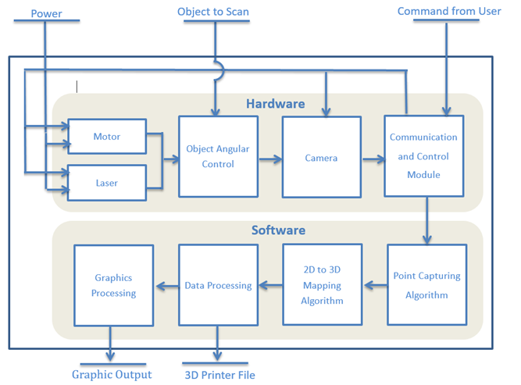

Figure B.2.2 System Block Diagram of Laser Line Scanner

As Figure B.2.2 illustrate, a motor rotates a plate on which an object is placed while a laser shines a continuous line on the object for the cameras to capture. The image data is then transmitted to a computer. The collection of 2D images is computed to extract 2D points, which are mapped to 3D points in space. The 3D data is further processed to certain formats suitable for 3D printing and graphical display. Please refer to Appendix C for visual descriptions of the algorithms employed, and Appendix D for images of the design setup.

**B.3 Work Plan**

This section will focus on the planning aspect of the project. Work breakdown, labour division, resource scheduling, budget forecasts, Gantt charts and feasibility assessments are presented in this section.

**B.3.1 Work Breakdown Structure**

The project has been decomposed into various stages and tasks, as classified in Figure 3.1.

The text description below is intended to provide additional methodological and technical descriptions on each of the tasks identified in Figure 3.1.

Stage 1 - Project Goal Setting and Administrative Items

1. Create project proposal, compare existing alternatives, selection of solution from alternatives, project feasibility assessment
2. Work distribution and Gantt Charts
3. Research and purchase required project material and equipment
4. Write the Project Proposal

Stage 2 - Developing Basic Scanner Hardware

1. Design and assemble scanner’s mechanical components.
2. Write Arduino code to control the motor and laser according to input signals.
3. Develop and establish communication protocols and channels between the Arduino hardware module and the main software.
4. Build power circuitry and system interconnection circuitry.
5. Develop communication and control protocols between the connected camera and the software, and enable the software to store image files in the computer’s memory.
6. Create and use benchmark software to test hardware functionality.
7. Refine the mechanical setup of the hardware to enhance precision and control.

Stage 3 - Developing Data Acquisition Software

1. Design high level pixel extraction algorithm.
2. Develop program to extract the points of the laser beam from the rest of the captured image.
3. Develop calibration tool that will allow scaling of image pixels to actual length in centimeters.
4. Produce high level algorithm for converting extracted 2D Cartesian points to 3D Cartesian points.
5. Test the software program previously developed.

Figure B.3.1 Brief Breakdown of Project Tasks and Task Coordinators

|  |  |  |
| --- | --- | --- |
| Item | Brief Description | Coordinator |
| S1 | Project Goal + Getting Started |  |
| 1.1 | Project Selection + Assessment | Sen |
| 1.2 | Project and Work Breakdown | Sen |
| 1.3 | Material Research + Purchase | Emily |
| 1.4 | Constructing Proposals | Emily |
| S2 | Scanner Hardware |  |
| 2.1 | Design and Assemble Mech. Parts | Sen |
| 2.2 | Hardware (Arduino) Programming | Sen |
| 2.3 | Define System Comm. Protocols | Emily |
| 2.4 | Build Hardware Circuitry | Sen |
| 2.5 | Implement System Comm. Module | Emily |
| 2.6 | Create + Test Benchmarks | Sen |
| 2.7 | Refine Mechanical Setup | Sen |
| S3 | Data Acquisition |  |
| 3.1 | Pixel Extraction Algorithm | Sen |
| 3.2 | Algorithm Implementation Details | Emily |
| 3.3 | Calibration and Scaling Tool | Sen |
| 3.4 | Data Mapping Algorithm | Emily |
| 3.5 | Implement Data Mapping Code | Sen |
| S4 | Display Data on Monitor Screen |  |
| 4.1 | Create OpenGL Panel and Draw Dot | Grace |
| 4.2 | Add Function: Panel Loads Data | Grace |
| 4.3 | Add Function: Rotation | Sen |
| 4.4 | Add Function: Zooming + Scaling | Emily |
| S5 | Updating Hardware and Software |  |
| 5.1 | Add 2nd Camera to Hardware Setup | Sen |
| 5.2 | Update Software to Support 2nd Camera | Emily |
| 5.3 | Add New Features to Illustrator | Grace |
| S6 | 3D Printing Files |  |
| 6.1 | Meshing 3D Points | Grace |
| 6.2 | Texture Smoothing | Sen |
| 6.3 | Noise Elimination | Sen |
| 6.4 | Save and Load Files | Emily |
| 6.5 | Print Function | Emily |
| S7 | Optimizations |  |
| 7.1 | Upgrade Hardware | Sen |
| 7.2 | Upgrade Software | Emily |
| S8 | Final Preparations |  |
| 8.1 | Quality Assurance | Grace |
| 8.2 | Final Report | Sen |
| 8.3 | Design Fair Items | Emily |

Stage 4 - Displaying Data on Monitor Screen

1. Create an illustration program using OpenGL. It must be able to create a drawing panel, open a 3D image file, and display the imported 3D image.
2. Modify the coordinate conversion program to save data into the file compatible for the illustration program.
3. Modify the illustration program to allow the rotation of objects and points.
4. Add functions to allow zooming and scaling.

Stage 5 - Updating Hardware and Software According to Design Review Feedback

1. Add additional camera to hardware setup to enable acquisition of top view data
2. Update software to support additional data processing from 2nd camera
3. Add new features to illustrator for usability

Stage 6 - 3D Printing Files

Note: In order to have 3D printers print objects, the object file must specify the model as a solid object, and not a set of floating dots in 3D space. These points needs to be meshed and saved in a specific format compatible for most 3D printers.

1. Mesh 3D points into polygons using data processing algorithms that will connect the points and convert them into surfaces .
2. Develop a smoothing algorithm which will delete points that are too close to each other. This will make the image smoother and computations run faster, at the expense of model resolution.
3. Develop noise detection algorithm which will detect noises in the form of floating dots isolated in 3D space, and will remove such points from the data set.
4. Develop a save function for saving meshed data into a 3D printer compatible file .
5. Develop a print function to send produced files to a 3D printer.

Stage 7 - Developing Improved Scanner Hardware

1. Improve the existing hardware by laser strength amplification, laser length extension, camera sight and angle adjustments. Additionally, variable laser and camera angular separation using motors can reduce obstructed blind spots.
2. Improve calibration method to account for slight camera view distortion with respect to points of varying heights and planar positions.

Stage 8 - Testing and Documentation

1. Quality assurance by testing the system with described functionalities and objectives.
2. Produce final reports in required formats by this course.
3. Design Fair preparation, including presentation layouts, demonstration strategies and presentation material.

**Appendix C Blind Spot of the Camera**

This section shows the object, laser, and camera configurations that causes the laser line to be hidden from the camera.

As seen from the image below, due to the angle between the laser and the camera, it is possible that when an object with edges is being scanned, the laser shines on one surface while the camera is capturing the image of an adjacent surface. When this occurs, the camera will not be able to capture the laser beam shining on the vertical surface because the edge is blocking the laser beam from the camera’s view.

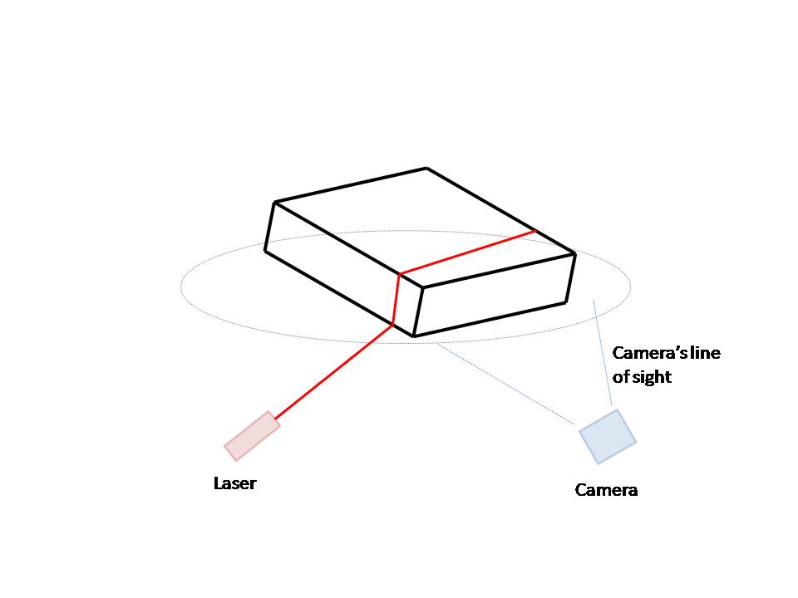

Figure C.1 Camera’s Blind Spot

**Appendix D Height of Object vs. Camera’s Angle of View**

As seen from the image below, the height of the object that can be successfully scanned is limited by the camera’s specifications, specifically the camera’s angle of view. Object 1 and object 2 in the image below are of the same size. However, object 1 is unable to completely fit into the camera’s frame due to the camera’s limited angle of view and the short distance between the object and the camera. Although we are able to completely fit the object into the camera’s frame by moving it further from the camera, as seen with object 2 being further from the camera and being able to fit within the camera’s angle of view, we cannot increase this distance indefinitely since our goal is to create a portable system. And thus, due to the limited distance we can have between the camera and the object, and the camera’s limited angle of view, the height of the object the scanner is able to scan is limited.

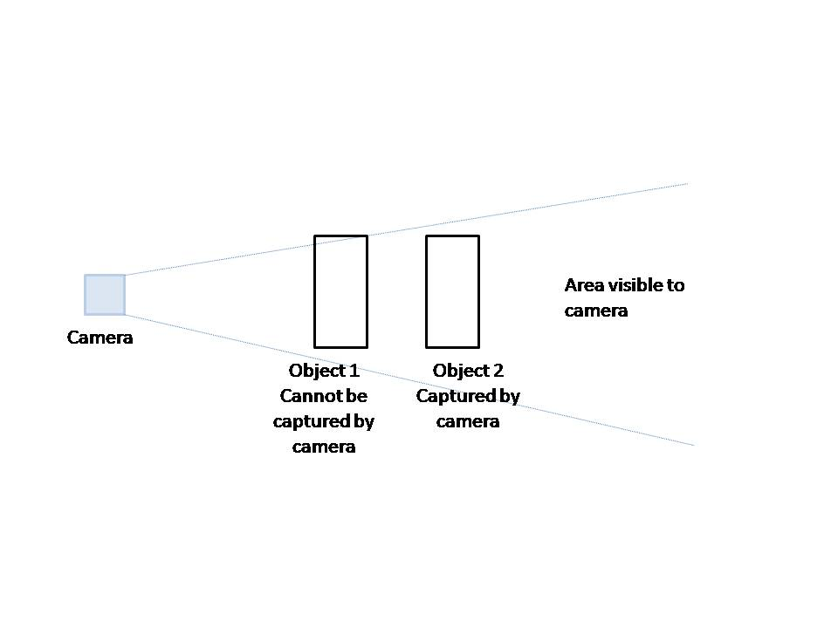

Figure D.1 Height of Object vs. Camera’s Angle of View

**Appendix E Scanner Prototype**

This section includes an overview of the various features of the 3D scanner prototype, including images of the prototype from various angles as well as a basic description of each image.

Figure E.1 below shows the exterior of the prototype. The 3D scanner is enclosed within a box to prevent external light from being captured by the camera causing unwanted noise.

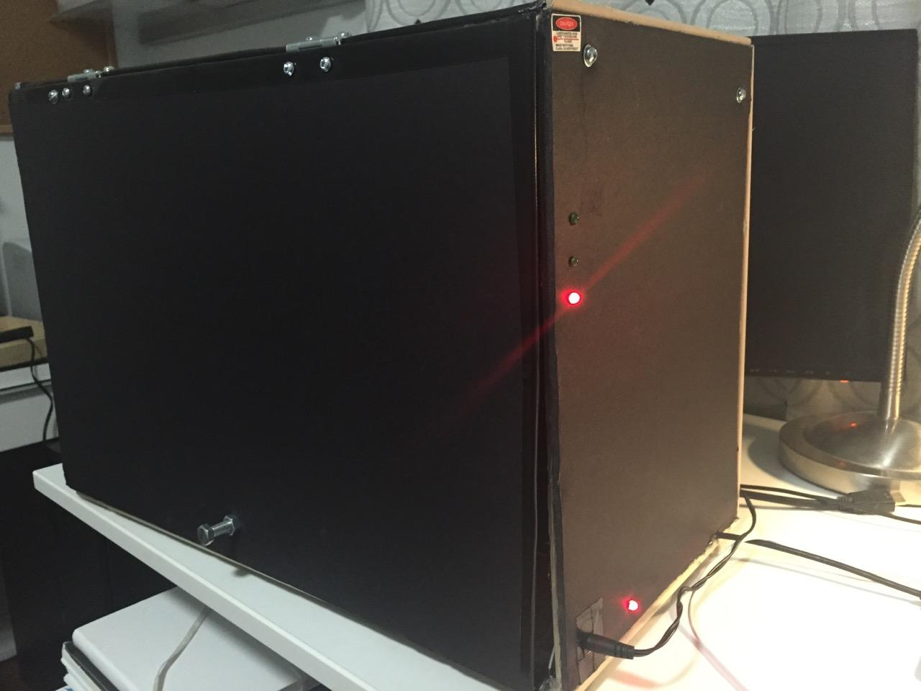

Figure E.1 Prototype Exterior

The various components of the 3D scanner is shown in Figure E.2 below. It includes a laser and two cameras (top right corner), a rotating plate (bottom left), a motor (under the rotating plate, not shown in figure), and the hardware control circuit (bottom right).

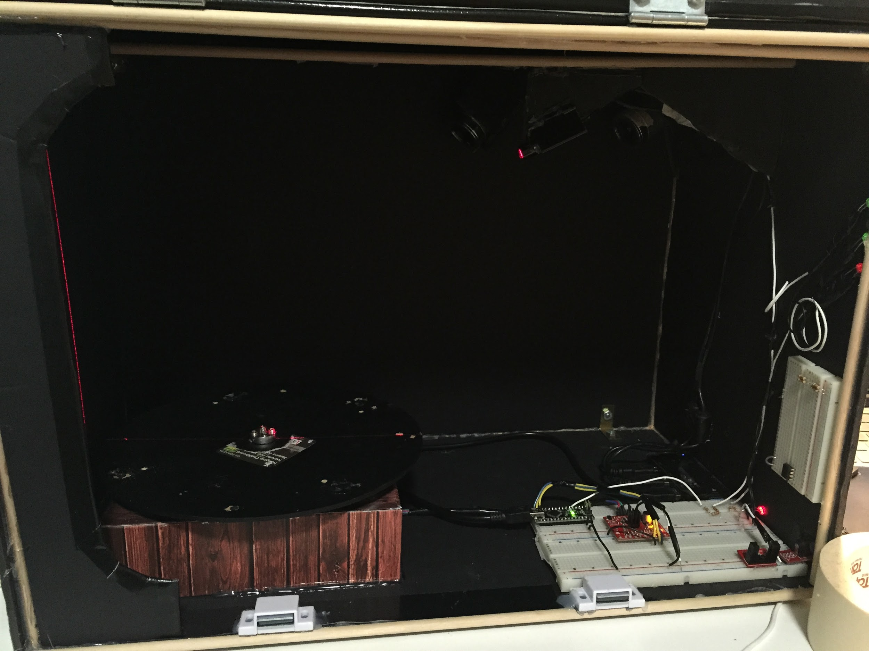

Figure E.2 Prototype Interior

The laser and cameras configuration is shown in Figure E.3 below. As seen in the figure, the laser and cameras are not directly next to one another, but rather at an angle. The two cameras are placed at different angles and locations to enable a side view and a top view of the object. All three components are pointing towards the center of the rotating plate (bottom left corner).

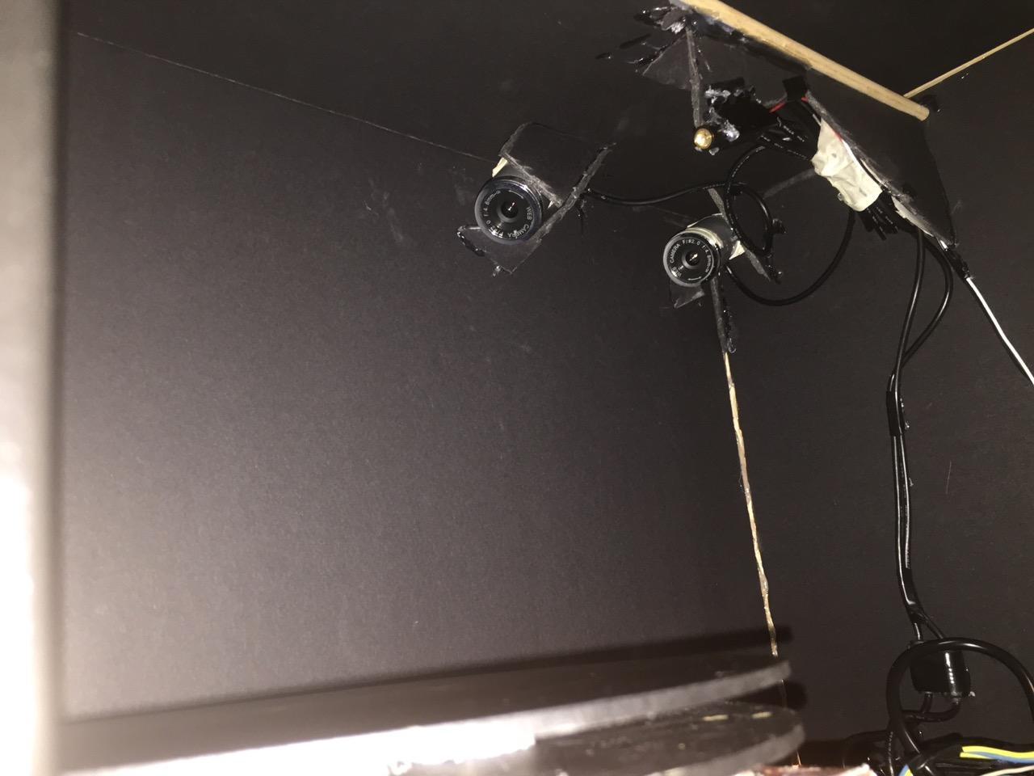

Figure E.3 Camera and Laser Configurations

The rotational plate with the lazy Susan is shown in Figure E.4 below. As seen in the figure, there are two plates, connected with various cylindrical supports. The motor is connected to the bottom plate, and provides the rotational torque to rotate the bottom plate. As the two plates are connected, the top plate will rotate with the bottom plate. A lazy Susan is placed between the bottom plate and a fixed support. This system allows the motor to rotate the object that’s placed on the top plate without putting any weight on the motor.

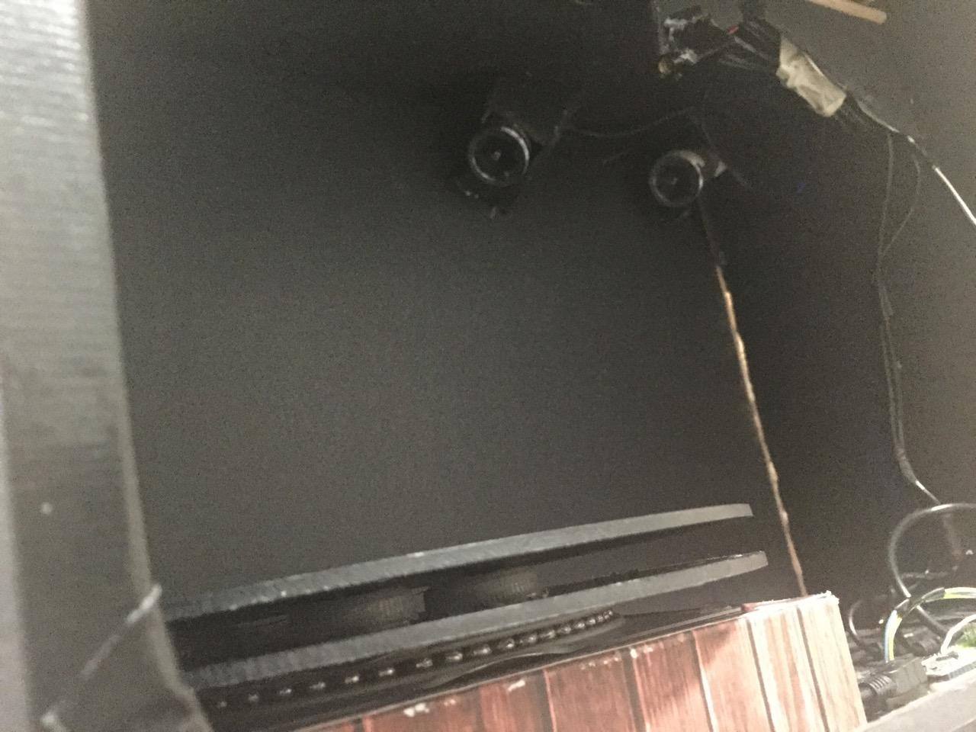

Figure E.4 Lazy Susan System

**Appendix F Camera Distortion**

This section explains the distortion of the far camera. Figure F.1 below is the scan from the top camera with the distortion. Figure F.2 below is the scan from the side camera without distortion. The object being scanned is a rectangular box. As seen from the scans, the top camera distorts the edges of the object, making them seem curved rather than straight. Further, there appears to be a black hole in the center of the image. Lastly, the top surface seems to be curving upwards, rather than being a flat surface. This suggests that the team will need to account for all possible distortions in order to scan objects with both cameras simultaneously.

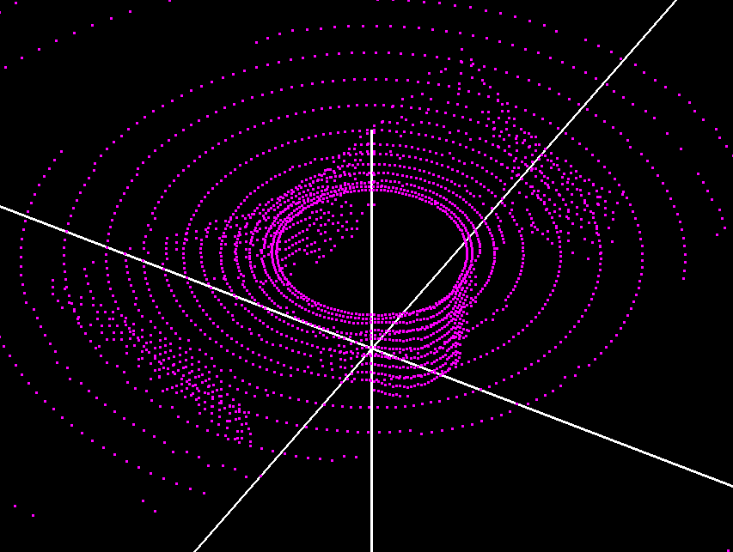

Image F.1 Top Camera View

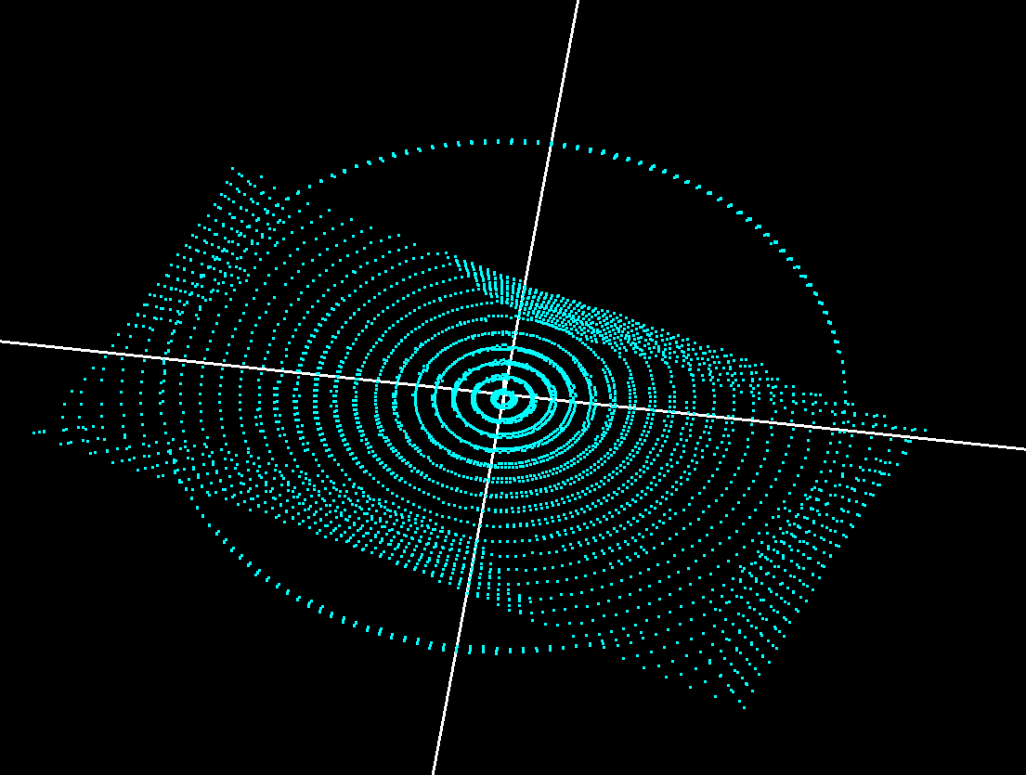

Image F.2 Side Camera View

**Appendix G 3D Graphics Display on Monitor**

The way the team displays 3D data of the scanned object on a monitor is described in the sections below.

Figure G.1 shows the control window. Users are able to rotate the object, move the object, and display the object in various styles. The styles of display is described in detail below.

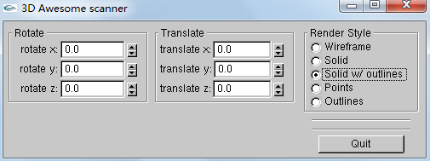

Figure G.1 Graphics Display Control Console

The user is able to view the object as the 3D points that has been scanned and computed (Figure G.2). This corresponds to Points mode in the control console.

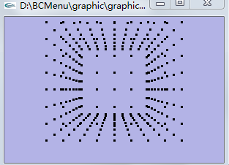

Figure G.2 Points Display

Users are also able to view the object by showing only the edges of the object (Figure G.3). This is Outlines Mode.

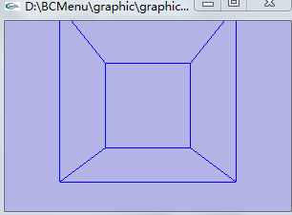

Figure G.3 Outlines Display

The user can view the object as a solid that’s filled in with a color with Solid Mode (Figure G.4).

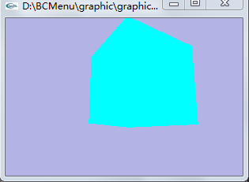

Figure G.4 Polygon Display

The user can also view the object with the computed meshed surfaces in Wireframe mode (Figure G.5).

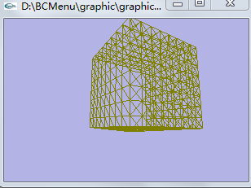

Figure G.5 Mesh Surface Display

Finally, the user can view the object as a solid that’s filled in with color, and outlined with the computed meshed surfaces (Figure G.6). This is Solid with Outlines mode.

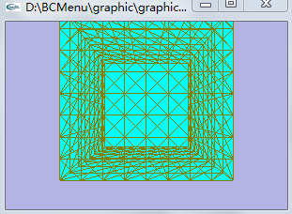

Figure G.6 Color Filling Mesh Surfaces Display